Further Tools and Resources

LTA Volunteer Toolkit: https://lta.org.uk/volunteering/volunteer-toolkit/

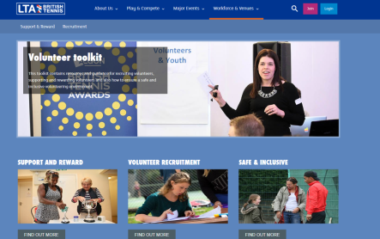

Club Matters (Sport England): https://sportenglandclubmatters.com/club-people/volunteers/

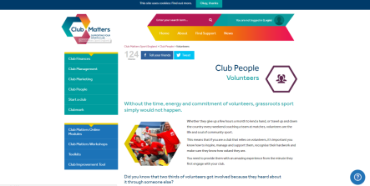

Sport and Recreation Alliance: https://sportandrecreation.org.uk/pages/volunteering-recruit-and-retain

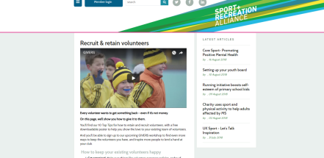

Join In (powered by Do-it): https://doit.life/join-in/app/#/ecosystem/profile

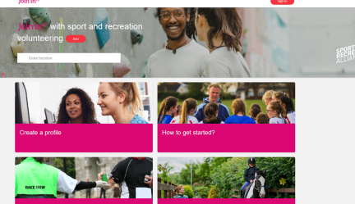

NCVO: www.ncvo.org.uk
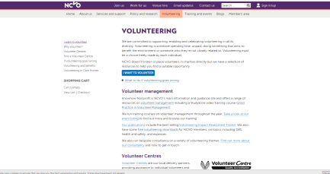

For any support or guidance on any of the above, or in volunteering more generally, please contact the Volunteering Team: volunteer@lta.org.uk or your LTA Regional Team.

